Lab 1
  - Project assignment of Software engineering

- Allocate groups and choose topics
- Analysis by systems thinking
  - What is the system about?
  - A framework or model of the system including parts and interrelations (E.g., http://www.w3.org/TR/mmi-framework/ )
  - Activity model of the system
>>> Make decisions
  - What functions are going to be changed/developed?
  - For each process/function, sketch a state/activity diagram/… document business rules
- Determine which SW development process
- Planning using MindMap/Visio (TimeLine, Grantt Chart) Project plan template
- Submit the report of sprint planning meeting and the draft of project plan document including the highlighted sections.
- Create a Discussion Board on Blackboard (Or any suitable platform) for daily/weekly team meeting activities (Optional). Show it at the review sessions and presentation session.
- Requirements specification (prepare)

REFERENCES IN A PROJECT PLAN DOCUMENT
1. Overview
General description of the developing framework / functions
…
2. Goals and Scope
3. Organization
4. Resource Requirements
  - Hardware Resource
Items | Quantity | Description | Purpose | Price | Total Cost | Date needed
Lenovo System x3500 M5 | 1 | System Server | Data Server | …. | …. | …..
…. | … | …. | …. | … | … | …
Total Cost:

  - Software Resource
Application | Quantity | Description | Purpose | Price | Total Cost | Date needed
MS Windows 10 Pro 64bit | 10 | Operating System | PC’s OS | …. | …. | …..
…. | … | …. | …. | … | … | …
Total Cost:

  - Human Resource
Name | Name of Organization | Project Role | Required Skills | Phone | Email | Salary/month
…. | …. | Project Manager | ……. | …… | ….. | ……
….. | …. | Business Analyst | ….. | ….. | ….. | …..
Total Cost:

5. Schedule
5.1. Work breakdown structure
There are two standard methods of creating WBSs: top-down and bottom-up approaches.
- Top-down approach: starting with the most significant items of the project and break them into subordinate items.
- Bottom-up approach: First, identify as many specific tasks related to the project as possible, then aggregate the particular tasks and organize them into summary activities or higher levels in the WBS.
Example: An example of using top-down approach to create a WBS
Project Name: ONLINE BOOKSTORE SYSTEM
Following the Software Development Life Cycle, the process includes: Requirement Analysis, Design, Implementation, Testing, Deployment and Maintenance.
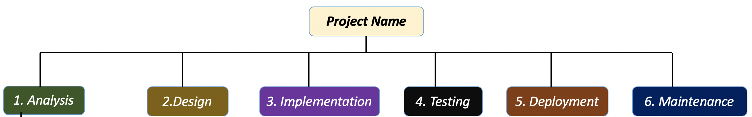
Then, in each phase, you break it into smaller tasks. For example, in the Analysis phase, you can break into 3 activities, which are Gathering business requirements, creating process diagrams, and performing a detailed analysis.
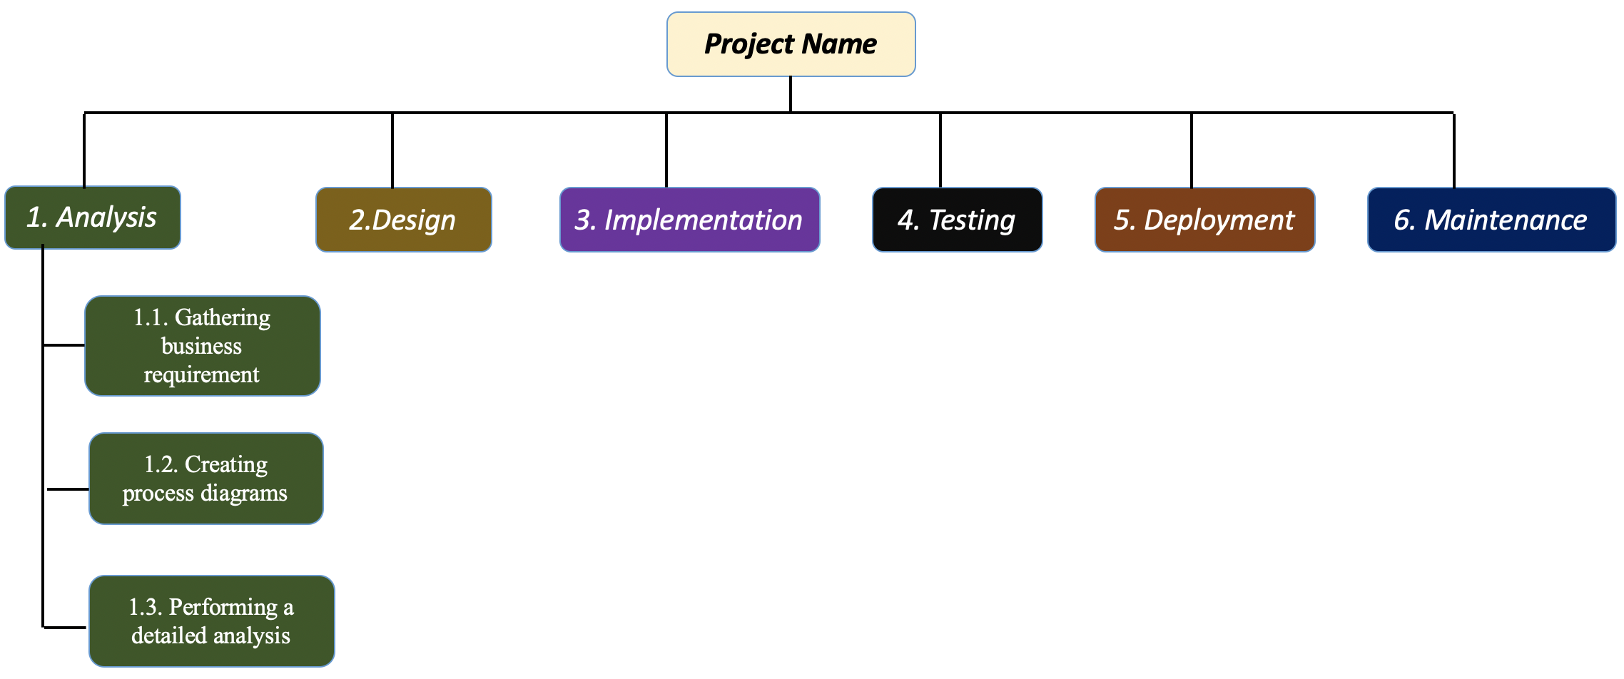
Then, continue breaking them into smaller ones.
5.1. Schedule and milestones

6. Risk Management
In this part, a list of identified risks and other information are defined.
- Risk Category: Some common categories are scope, schedule, cost, quality, HR.
- Risk title: a one-sentence description of a risk.
- Affect: A narrative description of the potential impact on the project.
- Probability: the likelihood of risk to happen. You can use Low, Medium, High
- Impact if the risk occurs: You can use Low, Medium, High
- Risk response plan: Actions to respond the risk.
Examples:
Risk ID | Risk Category | Risk Title | Affect | Probability | Impact | Risk response plan
001 | HR | Members lack of team corporation, or weak participation | This can slow down the progress of the project, produce unreliable result from the uncooperative work | Medium | Low | Organize team members so that they can easily get along with each other. Solve all the conflicts that are existing among the team members
002 | Requirements | Additional requirements are added | It effects on the project progress | High | Medium | Hold a meeting to update schedule and plan
003 | Organization and Management | Project is running over the budget | The project has to be stopped if the team ran out of the budget | Medium | High | Project Manager must propose a new saving plan or financial management

7. Delivery Plan
8. Security Aspects
9. Abbreviations and Definitions
10. References
11.Product Backlog
The product backlog lists all the tasks and specifications required to complete the final product.
Example: A product backlog includes the following:
  - Story name and description – This is a brief identifying description of the task to be performed by the backlog item.
  - Status: the status of backlog item. It can be Open (initial status), In progress and Complete
  - Sprint : The sprint ID that this story belong to
  - Priority: The priority of the backlog item. Values for priority are Low, Medium, and High.
  - Estimated days: estimated duration to finish the task.
  - Comments: You can add comments here to add key detail or explanation to the story. For larger definitions, use external tools and materials.
StoryID | Story Name and description | Status | Sprint | Piority | Estimated days | Comments
001 | As a member, I want to login to the site, so that I can do online shopping | Open | 1 | High | 7 days
… | …. | … | … | … | … | …

12.Sprint Backlogs
The sprint backlog is smaller in scope and less dynamic than the product backlog. When items are moved from the product backlog to the sprint backlog, they are broken down into more detailed tasks.
Example: A sprint backlog includes the following:
  - Tasks: define all tasks belong to the sprint.
  - Responsibilties: members in charge

Sprint ID: Sprint Name (ex: Sprint1- System login)
Tasks | Responsibilites | Monday | Tuesday | Wednesday | Thursday | Friday
Define the use case and requirements for the login function | Team | x hour(s) | …. | …. | … | …
Design login function | Designer | … | … | … | … | …
… | … | …. | …. | … | … | …

13.Members’ Contributions

